Muslim (1)—Its Founder

Islam is a religion. Its follower is called a Muslim. Arabic word “Islam” is based on the root “slm”, which means peace or surrender to God, its meaning will be something like “the state of peace through following God’s guidance.” And a Muslim will be “one who is in a state of peace by following God’s guidance.”

Our neighbor is building a school campus, New Horizon School, and it is a K-6 Muslim School.

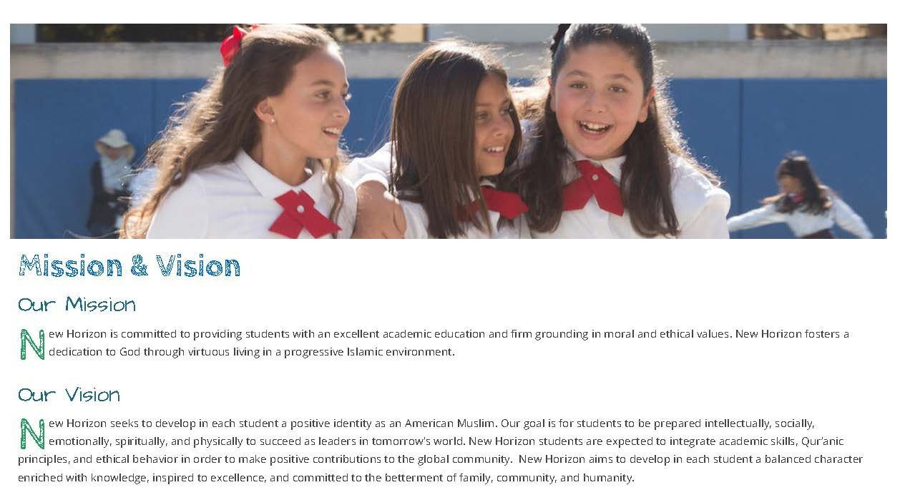
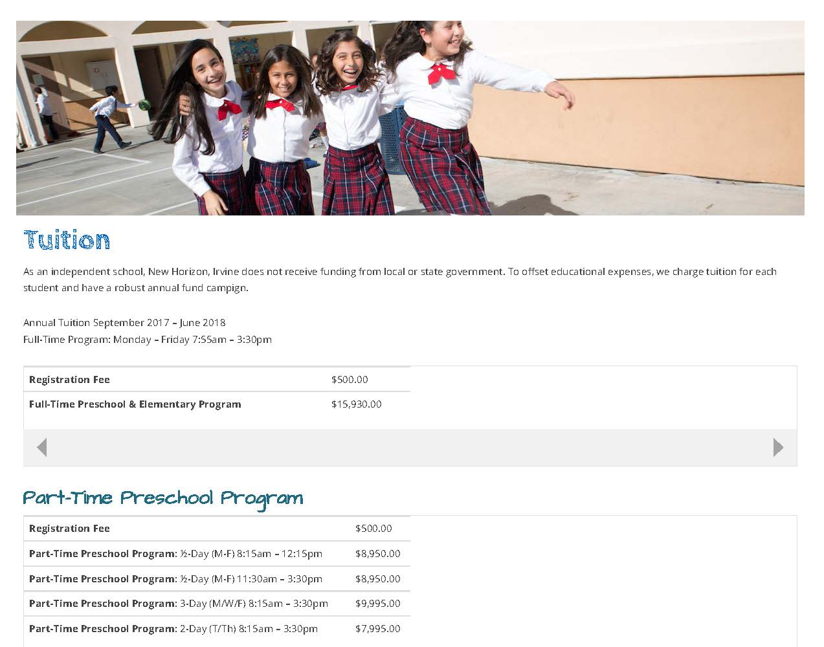

We have an offer from a Japanese buyer who is paying cash and hopes to move in February. If the price works out between two sides, then we the pastors are out in wandering again, waiting to move in to the facility of 2 Faraday. This transaction is done before the bigger sign of for sale gets permission from our HOA to be posted in the Bake Commerce Center entrance. We feel that the Lord is pushing us forward.

One of the reasons that the Lord is pushing us to have the building is to get us ready for the task that he has for our church. A Jesus contact with the Muslims. Honestly, this will be the first time that I get involved in the Muslim ministry, I am not confident that I can do it, but again, who in the history of the gospel sharing, which disciple of Jesus, was confident in any of the tasks ahead of them? Every challenge all looks so formidable, so we welcome the task that comes our way, and ask the Lord of Hosts to lead us forward. This is the verse that encourages us:

¹³約書亞靠近耶利哥的時候，舉目觀看，不料，有一個人手裡有拔出來的刀，對面站立。約書亞到他那裡，問他說：你是幫助我們呢，是幫助我們敵人呢？¹⁴他回答說：不是的，我來是要作耶和華軍隊的元帥。約書亞就俯伏在地下拜，說：我主有甚麼話吩咐僕人。¹⁵耶和華軍隊的元帥對約書亞說：把你腳上的鞋脫下來，因為你所站的地方是聖的。約書亞就照著行了。【書 5:13~15】
¹³Now when Joshua was near Jericho, he looked up and saw a man standing in front of him with a drawn sword in his hand. Joshua went up to him and asked, "Are you for us or for our enemies?" ¹⁴"Neither," he replied, "but as commander of the army of the LORD I have now come." Then Joshua fell facedown to the ground in reverence, and asked him, "What message does my Lord have for his servant?" ¹⁵The commander of the Lord's army replied, "Take off your sandals, for the place where you are standing is holy." And Joshua did so. 【Josh 5:13~15】

This is the most comforting message that I found from the Lord. As I am fretting about the Muslim ministry ahead of us, (We cannot escape this spiritual battle, I am getting to understand why 9800 Muirlands was first in our search list, and the same time we have eyed the parcel of vacant land next to 9800 Muirlands, and this vacant land is now under construction for New Horizon Muslim School. Do you still remember we prayed for this land for so long, and we encircled this land and prayed for Jericho to fall, remember? Now we understand we were praying for this New Horizon School.) I found out that our Lord is already with the drawn sword ready to lead us into this spiritual battle.

It is good then that we spent a few sermons to understand the religion of Islam, its founder, its religion, and its people. With proper understanding, we are better equipped to have “Jesus encounter with the Muslims”. I am amused by God’s design of first leading us to encircle the 9800 Muirlands Bldg, and the plot next to it, and then lead us to 2 Faraday, which looks like a castle. Too much coincidence to be without a meaning!!! And the meaning? A spiritual battle that I would call it “Jesus encounter with the New Horizon”.

So, let us first understand the Islam, the religion that the New Horizon School is promoting and trying to instill in the hearts and minds of these beautiful young people. So that we know how best to engage.

Illustration 1:
There is a story of a Muslim converted to Christianity, and he was not happy for the way that he was cared for in his now found faith. So this professor invited him to come to his country, gave him a car, found him a job and asked him to come to his church, and at the end of a few months, he still not satisfied. Because religion to him means the entire person commitment, but he has not experienced that.

You see, in western education, we are taught to separate our faith from our living. The entire western world is humanitarianism, and the faith is the addition on the side. This is not the Muslim way. Islam is everything for a Muslim: A man would blow himself up for the name of Islam and his mom will encourage him to do so.

So to understand how a religion would ask for such a dedication, we have to start with its founder—Muhammad (570-632).

The Prophet Muhammad
Muslims believe that Islam is a faith that has always existed and that it was gradually revealed to humanity by a number of prophets, but the final and complete revelation of the faith was made through the Prophet Muhammad in the 7th century CE.
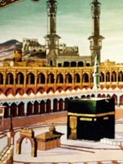Muhammad was born in Mecca in Saudi Arabia ©
Muhammad was born in Mecca in Saudi Arabia in 570.
He was a deeply spiritual man, and often spent time in meditation on Mount Hira.
The traditional story of the Qur'an tells how one night in 610 he was meditating in a cave on the mountain when he was visited by the angel Jibreel who ordered him to recite.
Once Jibreel mentioned the name of Allah, Muhammad began to recite words which he came to believe were the words of God.

The Qur'an
During the rest of his life Muhammad continued to receive these revelations. The words were remembered and recorded, and form the text of the Holy Qu'ran, the Muslim scripture.

Preaching
Believing that God had chosen him as his messenger Muhammad began to preach what God had revealed to him.
The simple and clear-cut message of Islam, that there is no God but Allah, and that life should be lived in complete submission to the will of Allah, was attractive to many people, and they flocked to hear it.

The Hijrah
Muhammad's popularity was seen as threatening by the people in power in Mecca, and Muhammad took his followers on a journey from Mecca to Medina in 622.
This journey is called the Hijrah (migration) and the event was seen as so important for Islam that 622 is the year in which the Islamic calendar begins.

The return to Mecca
Within ten years Muhammad had gained so many followers that he was able to return and conquer Mecca.
From this time on he was generally accepted by the faithful as the true final Prophet of God.
Muhammad continued to lead his community both spiritually and in earthly matters until his death in 632.

A few observations worth noting from this brief introduction of the person Muhammad

1. The person being the author of entire Qu’ran, he is a very important person; that is why the Muslims called him the Prophet. Being the prophet through whom God gave him the word, Muhamad needs to be of great character. We will soon exam if it is the case.

2. The simple and clear cut message is that “there is no God but Allah, and that life should be lived in complete submission to the will of Allah.” By its core value, Islam will not allow other religions to exist besides it. Islam will demands a person dedicate in his entirety, living, politics, laws, and all to the Muslim teaching. It will not allow the western way of compartmentalize the life to study segment, recreation segment, political segment, and religious segment. The Islam has to trump them all.

3. Muhamad being the greatest and final prophet, total dedication of all facets of life to God thus to the prophet, it is inevitably the religious leader becomes the political leader and therefore, Muhamad is the supreme king to all. It is mostly achieved through human effort. Therefore, the struggle to supremacy is a way of Islamic life. Human struggle is forever the way to its success. It is most evidently seen in Shiite and Sunni Muslim sectarian struggles.

Let us exam the observation #1 now:
According to Deuteronomy 13:1-5, there are 4 requirements to be a true prophet,

¹你們中間若有先知或是做夢的起來，向你顯個神蹟奇事，²對你說：我們去隨從你素來所不認識的別 神，事奉他罷。他所顯的神蹟奇事雖有應驗，³你也不可聽那先知或是那做夢之人的話；因為這是耶和華─你們的 神試驗你們，要知道你們是盡心盡性愛耶和華─你們的 神不是。⁴你們要順從耶和華─你們的 神，敬畏他，謹守他的誡命，聽從他的話，事奉他，專靠他。⁵那先知或是那做夢的既用言語叛逆那領你們出埃及地、救贖你脫離為奴之家的耶和華─你們的 神，要勾引你離開耶和華─你 神所吩咐你行的道，你便要將他治死。這樣，就把那惡從你們中間除掉。【申 13:1~5】
¹If a prophet, or one who foretells by dreams, appears among you and announces to you a miraculous sign or wonder, ²and if the sign or wonder of which he has spoken takes place, and he says, "Let us follow other gods" (gods you have not known) "and let us worship them," ³you must not listen to the words of that prophet or dreamer. The LORD your God is testing you to find out whether you love him with all your heart and with all your soul. ⁴It is the LORD your God you must follow, and him you must revere. Keep his commands and obey him; serve him and hold fast to him. ⁵That prophet or dreamer must be put to death, because he preached rebellion against the LORD your God, who brought you out of Egypt and redeemed you from the land of slavery; he has tried to turn you from the way the LORD your God commanded you to follow. You must purge the evil from among you. 【Deut 13:1~5】

1. He must be a true Israelite.
2. He must speak in the name of the Lord (Jehovah).
3. He must call men to living obedience to Jehovah and worship of Jehovah.
4. He must be tested and vindicated by the fulfillment of predictions made by him in the name of Jehovah, by the authority of Jehovah and in keeping with the character of Jehovah.

This is from Pentateuch, and the Muslim revered the Pentateuch as the word of God. Even if they do not agree with the 4 items that we mentioned above, there is one litmus test that the Muslims would not object, that is the prophet who demands the total obedience to God’s law which is pronounced through him must he himself in obedience to the law.

https://www.thespiritofislam.com/contact-us.html

570A.D. 8月20日出生, 610A.D.40歲時受到天使加百列的啟示. 開始接受啟示時, 全身發抖跑回家去, 見到妻子大嚷,“遮蓋我, 遮蓋我.”這時他的太太給他蓋上一件大衣, 這時天使長來說, “蓋被的人哪, 你應當起來, 你應當警告”(74:1-2) 自此時開始有定期性的啟示由加百列給他. 此加百列大有可疑.

他有9個妻子:

1. Khadiyah (哈蒂雅)

2. Sawdah (莎烏達)

3. Aisyah (阿伊莎)

4. Hafsa.

5. Zainah Bint Khuzaimah,

6. Zainah Bint Jahsh (彩綺納)

7. Maimunah.

8. Juwairiyah.

9. Ummi Habibah Ramlah.
三個妾:

10. Safiyyah

11. Rauhanah
12 Mariyah.

頭一位是原妻, 寡婦哈蒂雅(#1, 40歲時下嫁25歲的穆罕默德). 婚後25年原妻過世, 穆氏及連續娶其他女子. 阿伊莎(#3)訂婚時年僅8歲, 結婚時9歲. , 因阿拉的啟示就把它迎娶過來. 18歲就守寡.另一妻彩綺納(Bint Jahsh, #6) 原來是穆氏養子塞德(Zaid)的美妻, 後來因阿拉的啟示, 囑之離婚然後自娶之. 後面的兩個婚姻啟示有問題, 因為和神的屬性不合. 且可蘭經明文規定一個人可以娶4個妻子, “如果你們恐怕不能公平對待孤兒, 那末, 你們可以擇取你們愛悅的女人, 各娶兩妻, 三妻, 四妻;”(4:3). 但穆氏有12個. 可蘭經說, “真主嚴禁你們娶你們親生兒子的媳婦”(4:23). “他又嚴禁你們娶有丈夫的婦女”(4:24). 但身為頒布可蘭經的先知, 竟可以自己不守律法. 此先知的身分可疑, 頒布的經文不可信.

Was Muhammad illiterate?
Muslims claim that because Muhammad was illiterate, he could not have written the Qur’an, and thus the Qur'an is a miracle, Muhammad's primary miracle. This idea of illiteracy is supported in the Qur’an:
Sura 7:157: "Those who follow the apostle, the unlettered Prophet, whom they find mentioned in their own (scriptures), - in the law and the Gospel...
Sura 7:158 – Say: "O men! I am sent unto you all, as the Apostle of God, to Whom belongeth the dominion of the heavens and the earth: there is no god but He: it is He That giveth both life and death. So believe in God and His Apostle, the Unlettered Prophet, who believeth in God and His words: follow him that (so) ye may be guided."
Thus, the Qur’an’s very existence is testimony to Muhammad’s status as a prophet. There are a couple of problems with this position.
First, it is doubtful that Muhammad was illiterate. Recall that when he was being raised by his uncle, he traveled as a merchant, delivering supplies to various communities. He also traveled extensively with his first wife Khadijah, who hired him to help her with her trade business. Surely there must have been some sort of written record kept to document these transactions. The merchant trade cannot exist without written records of what and how much was shipped to whom.
Second, Muhammad’s illiteracy is irrelevant to the question of the existence of the Qur’an. Muhammad did not write the Qur’an; he recited it. Others wrote down what Muhammad recited, as the Qur’an was complied over several years. The Qur’an would have been written whether Muhammad could or could not read and write, so the argument is irrelevant.
Third, recent scholars have shown that the Arabic word ummi , translated as “illiterate,” does not mean illiterate, but rather means "one who has no book", or those who did not have a book revealed by God (sura 62:2) Thus, the Qur’an was revealed, not to an illiterate prophet, but to a prophet and people who did not have their own book revealed by God.
Sura 62:2 – It is He Who has sent amongst the Unlettered an apostle from among themselves, to rehearse to them His Signs, to sanctify them, and to instruct them in Scripture and Wisdom, - although they had been, before, in manifest error…
Fourth, the hadith includes numerous accounts of Muhammad writing.
Narrated Anas bin Malik:
Once the Prophet wrote a letter or had an idea of writing a letter. The Prophet was told that they (rulers) would not read letters unless they were sealed. So the Prophet got a silver ring made with "Muhammad Allah's Apostle" engraved on it. As if I were just observing its white glitter in the hand of the Prophet… (Sahih al-Bukhari, Volume 1, Book 3, Number 65)
Narrated 'Ursa:
The Prophet wrote the (marriage contract) with 'Aisha while she was six years old and consummated his marriage with her while she was nine years old and she remained with him for nine years (i.e. till his death). (Sahih al-Bukhari, Volume 7, Book 62, Number 88)
Narrated 'Ubaidullah bin 'Abdullah:
Ibn 'Abbas said, "When the ailment of the Prophet became worse, he said, 'Bring for me (writing) paper and I will write for you a statement after which you will not go astray.' But 'Umar said, 'The Prophet is seriously ill, and we have got Allah's Book with us and that is sufficient for us.' But the companions of the Prophet differed about this and there was a hue and cry. On that the Prophet said to them, 'Go away (and leave me alone). It is not right that you should quarrel in front of me." Ibn 'Abbas came out saying, ""It was most unfortunate (a great disaster) that Allah's Apostle was prevented from writing that statement for them because of their disagreement and noise. (Sahih al-Bukhari, Volume 1, Book 3, Number 114)
Thus, the claim that Muhammad was illiterate does not stand up to investigation. Moreover, it is irrelevant. Therefore, the claim that the Qur'an is Muhammad's sole miracle, and divinely inspired since an illiterate man could not have produced it, is also without merit.

This is the first sermon about Muslim.

http://newhorizonirvine.org/admissions/tuition-and-tuitionadjustment/ http://newhorizonirvine.org/ http://newhorizonirvine.org/about-us/mission-vision/ http://newhorizonirvine.org/about-us/history/ http://newhorizonirvine.org/about-us/school-facts/ http://newhorizonirvine.org/about-us/honors-testimonials/
ing.org/top-100-frequently-asked-questions
http://www.bbc.co.uk/religion/religions/islam/history/muhammad_1.shtml

